MODULE 4
Support Operations Labs
Lab 4.1 — GitHub as a Support Desk — Full Ticket Lifecycle
1.Create and Work 3 Mock Tickets
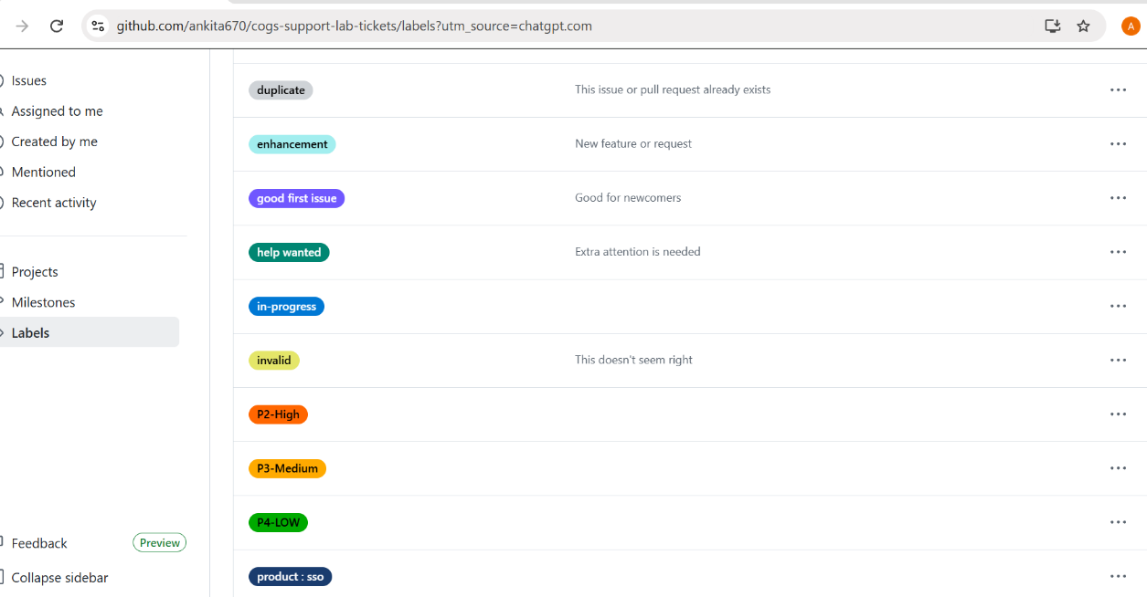
2. Create a Milestone

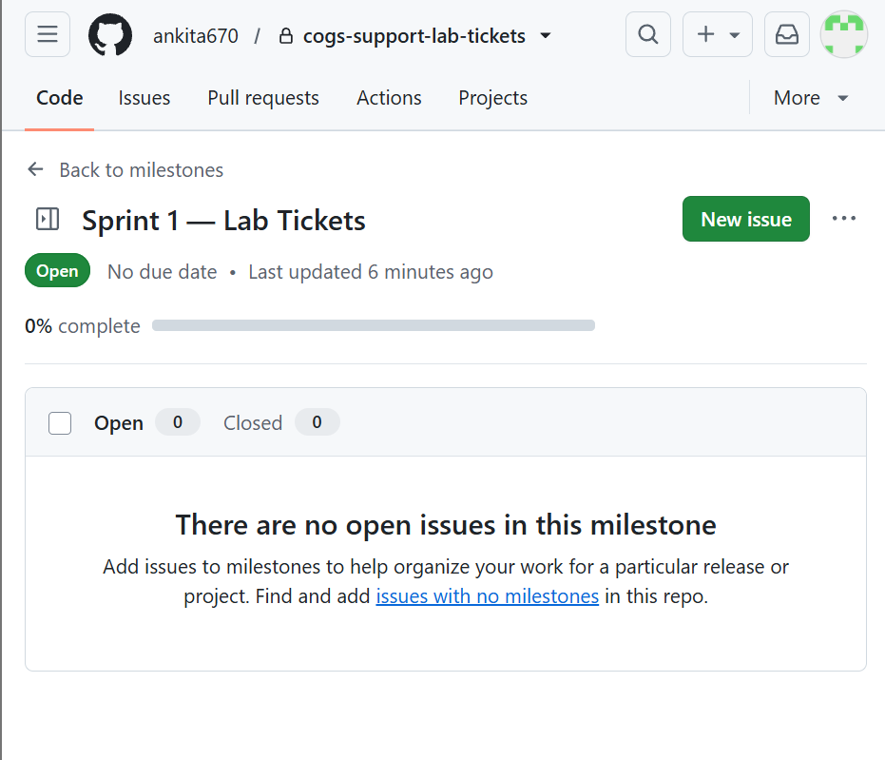
3> Columns Created.
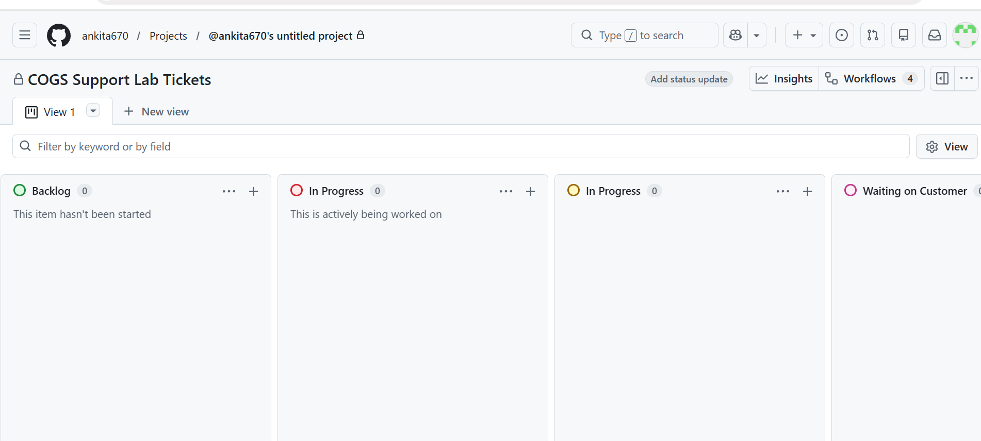
4> Ticket created
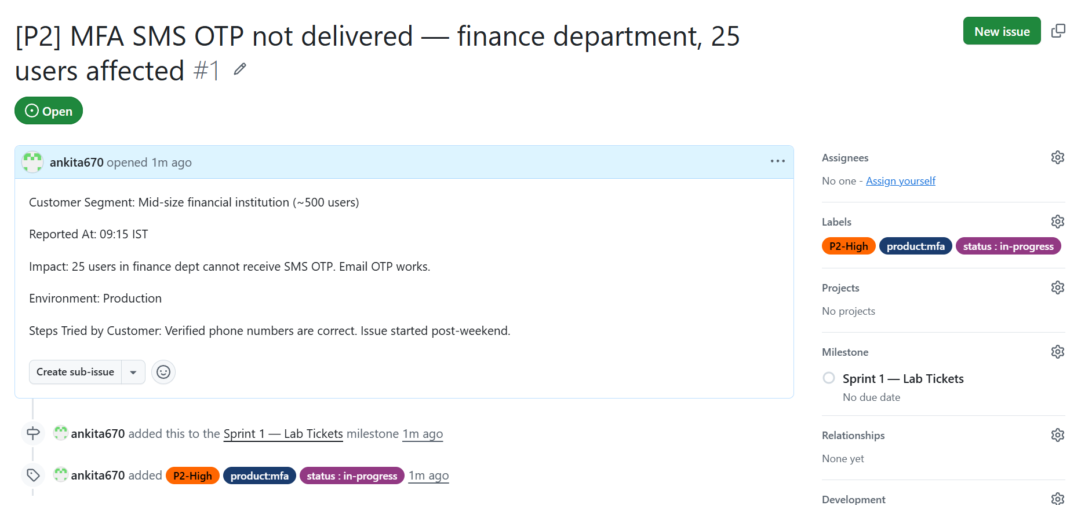
5> 3 Tickets has created
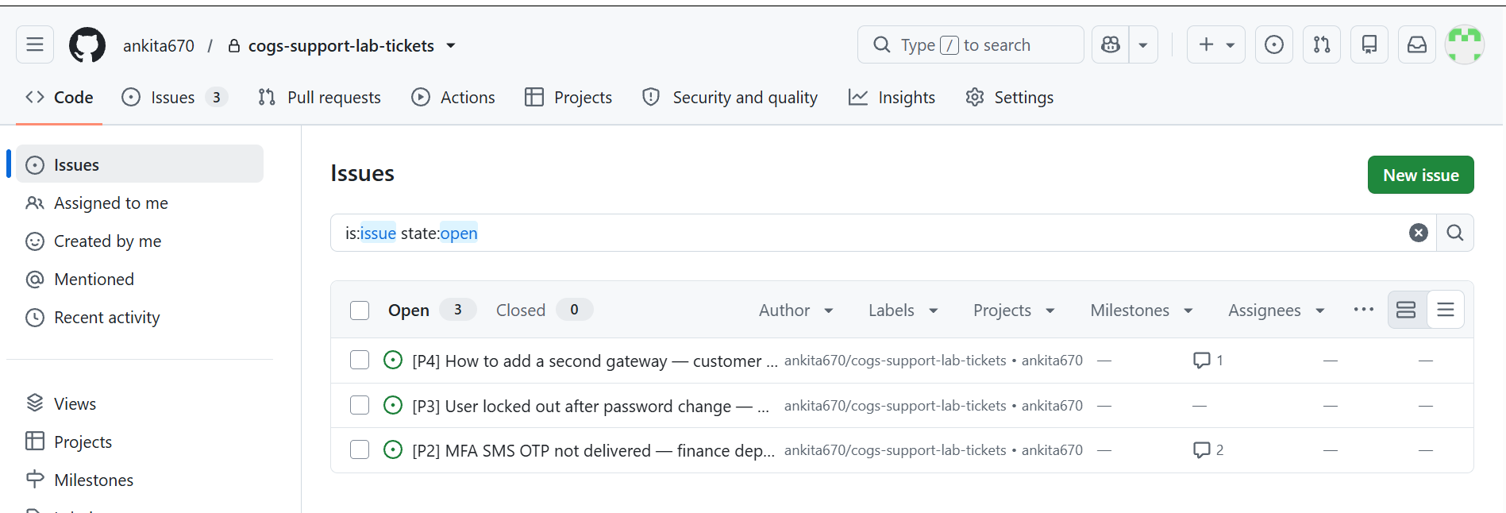

4.2 Lab 4.2 — PACE Handover + PIR — Git as Your Process Record

